TKC LONDON BULLETIN 07/02/15: MONTH OF ABUNDANCE LIFE

WELCOME TO THE KINGDOM CHURCH WHERE THE CAPTIVES ARE SET FREE AND OUR CHURCH MEMBERS ARE WEALTHY, HEALTHY AND WISE

OUR MISSION STATEMENT
We are the church that God has chosen to fulfil His purpose on the earth and to display His miracles and wisdom in its rich variety to all the unseen rulers and authorities in the heavenly places. Walking in authority and power, getting results and changing lives (Ephesians 3:10)

Event Alert: Come and join us at The Kingdom Church London for The Kingdom Millionaires Club meeting today at 4PM - 5:30PM all existing Kingdom Millionaire members pay £15 renewal fee of your Kingdom Millionaires subscription. If you are yet to join Kingdom Millionaires come and register for £30 one time registration fee.

Requirements to join Kingdom Millionaires;
- Have a vision of going into business/business projects
- Have to be a business owner / partnership
- Thinking of going into a business
Come and fellowship with other Kingdom Millionaire members, discover and learn key steps to success in becoming a millionaire and unlocking your millionaire potential! # Our very own Bishop will be sharing with us our first project for 2015, DON’T MISS OUT

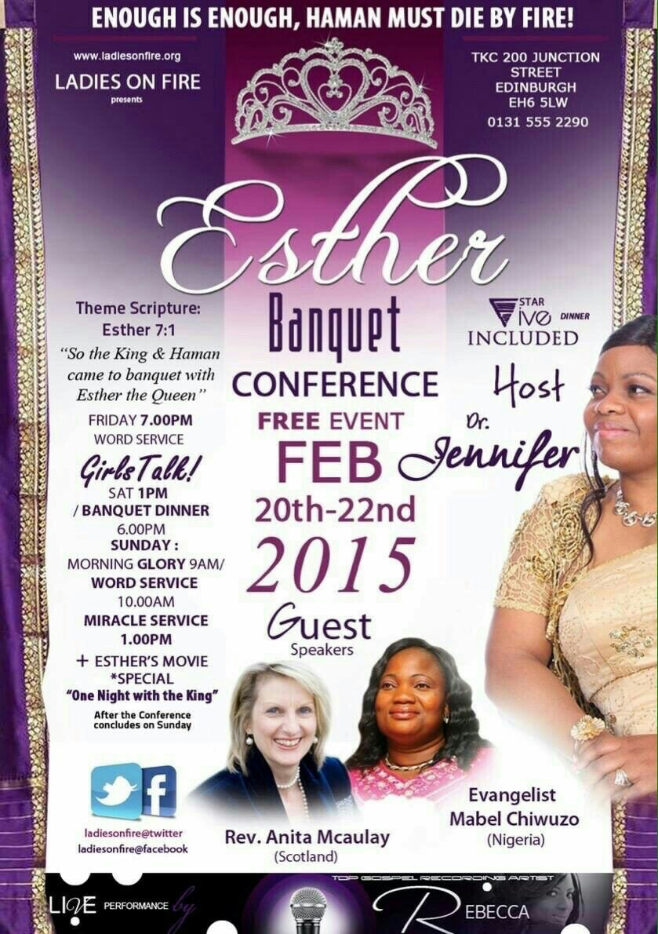

SUPER SUNDAY 08/02/15:

Super Sunday Services:

Morning Glory: 8AM - 9AM
Prophetic Hour: 9AM -10AM
TKC Leadership Meeting: 10AM - 10:30AM
Super Sunday Family Word Service:10:30AM - 1PM
Super Sunday Prophetic Miracle Service: 2PM - 4PM

Are you new?
Whether you’re just visiting or looking to stay, it is great to have you with us. Please feel free while in are in the house of God, find out more information about TKC and get connected into the community. We hope this bulletin will be helpful in knowing what happening in the church.

What to expect
The only thing we ask you to do is to relax, you are with people just like you. Whether you have been a church member, been here many times or never been here before, you can anticipate an encouraging and enlightening experience while attending The Kingdom Church London. With our many facilities such as TKC Church Bookstore, TKC Cafe for refreshments, toilets, baby changing facilities and more. If you need any assistance our ushering team is here to help.

UPCOMING EVENTS

20th – 22nd of February: Esther’s Banquet Conference in Edinburgh. For travel and accommodation arrangements please get in touch with the church manager or the ladies on fire coordinator

VALENTINE’S WEEKEND NEXT WEEK: To all the temporary singles www.rightmate.net has taken this opportunity to invite you to a valentines dinner at the Steak and Lobster, Bloomsbury hotel, warren street, London on 14th of February 2015 at 7pm. Come meet and mingle with other temporary singles. Admission fee is only £25 please confirm your attendance with Pastor Precious. If you are dating please bring that special someone and enjoy yourselves. Visit www.therightmate.net

We love you all and God bless you, Looking forward to seeing you here tomorrow on time at TKC Mega Miracle House, 93 Camberwell Station Road, London, SE5 9JJ Call Us For More Info On UK:0207 738 3668

From Bishop Climate & Dr Jennifer Irungu

Click here to manage your subscriptions
Powered By The Holy Spirit

